Conference Days - The Future of Free Trade Zones
June, 3 and 4
Whatever the name given, free trade zones (special economic zones, export processing zones, etc.) have become a major player in international trade and global value chain. Emerging and developing countries use them to attract foreign investment, boost their trade and speed up their industrialization. But, what about their economic and social performances?
Two conference days are organized to address these issues.
Website : ftz.dauphine.fr
Day 1
2015, June 3 - Free Trade Zones: a Model for Developing Countries?
University Paris-Dauphine, room Espace One, 1st Floor, Main Building

Registration is required: www.dauphine.fr/index.php?id=12082
8:30 Welcome
9:00 Introduction
Performances of Free Trade Zones (FTZ)
9:15 “Trade Performance of Free Trade Zones. A new database”, Aycil Yücer, University of Dokuz Eylül, Izmir & Jean-Marc Siroën, Paris-Dauphine University
9:45 « Decent Work and Export Processing Zones: an ILO perspective », Claude Akpokavie, International Labour Organization
10:15 "Special Economic Zones: Do they work? What matters for success?", Thomas Farole, World Bank
(by visioconference)
10:45 Break
FTZ Country Experiences
11:00 "What went wrong with India's SEZs?: Politics, Bureaucracy or Economics”, Aradhna Aggarwal, Copenhagen Business School
11:30 “The Free Trade Zone of Manaus: purposely and unwittingly results”, Mauro Thury de Vieira, Federal University of Amazonas (UFAM)
12:00 “Foreign Direct Investment in the Free Zone of Madagascar: Oasis or Mirage? » Herinjatovo Ramiarison, University of Antananarivo
12 :30 Conclusion

Day 2
2015, June 4th - The Free Trade Zone of Manaus: Success and Limits?
University Paris-Dauphine, room A709, 7st Floor, New Building A

Registration is required: www.dauphine.fr/index.php?id=12082
This day, which is dedicated to the Manaus Free Zone, is included in the program “Latin America and Caribbean Week”.
9:00 Welcome
9:30 “An overview of the Free Trade Zone of Manaus”, Marta Castilho, Federal University of Rio de Janeiro (UFRJ), Jean-Marc Siroën, Paris-Dauphine University , Ayçil Yücer, University of Dokuz Eylül, Izmir
10:00 “Manaus Free Trade Zone as Brazil´s development policy for the Amazon”, Renato Mendes Freitas, Superintendency of the Manaus Free Zone (SUFRAMA)
10:30 “Manaus Free Trade Zone: a comparative and value-added approach”, Mauro Thury de Vieira, Federal University of Amazonas (UFAM)
11:00 “Poverty and Inequality Dynamics in Manaus: the Legacy of the FTZ », Marta Castilho, Federal University of Rio de Janeiro (UFRJ), Marta Menendez and Aude Sztulman, Paris-Dauphine University
11:30 Questions
12:15 Conclusion
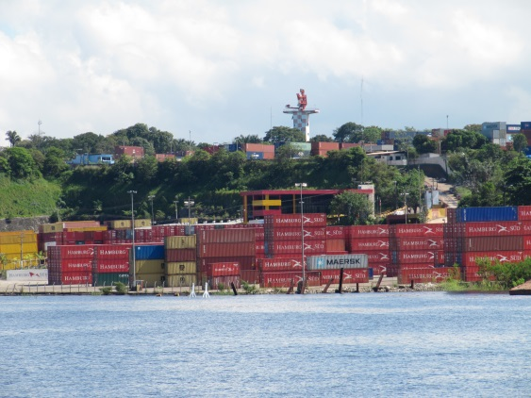 | 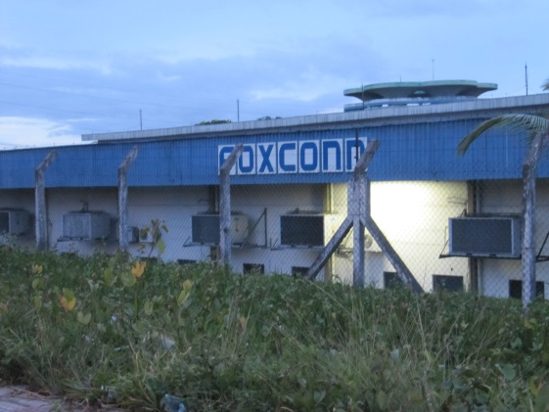
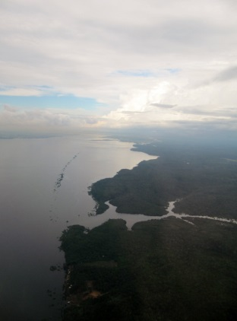 | 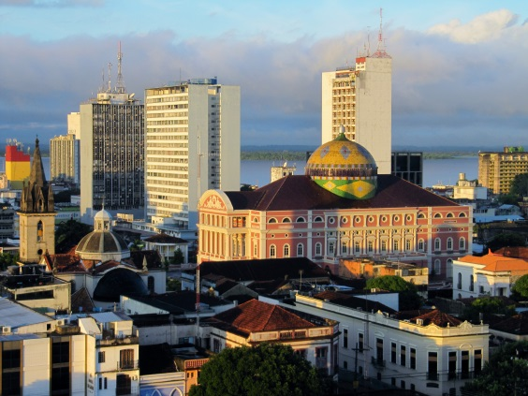
These two days are organized within the framework of a project funded by the French National Research Agency (ANR) as part of its program: "Les Suds II" (see: ftz.dauphine.fr)
Research has been led by the research centre DIAL (http://www.dial.ird.fr/)
DIAL associates Paris-Dauphine University and IRD (Institut de Recherche pour le Développement).
Aspects related to the contribution of FTZs to reducing poverty are also concerned by the European project (FP7) NOPOOR (www.nopoor.eu).

The second day is included in the program of the Week of Latin America and Caribbean.

This event also involves the Institute of Economics of the Federal University of Rio de Janeiro (UFRJ) and the Federal University of Amazonas (UFAM).

Map and access
http://www.dauphine.fr/en/directions-to-paris-dauphine-universitys-campus-at-porte-dauphine.html
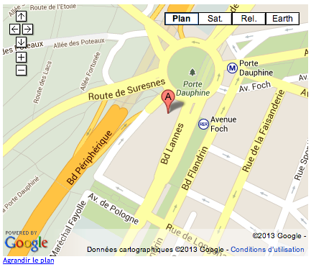 | By Public Transportation  - Bus: take PC1 Line and get off at the Porte Dauphine stop.  - Subway: take Line 2 (Nation - Porte Dauphine), get off at the Porte Dauphine Station and exit at Avenue Bugeaud  - RER (suburban trains) : take Line C and get off at the Avenue Foch station

